Cate Geiman

**Multi-species occupancy modeling notes**

[**Video**](https://www.youtube.com/watch?v=tj_OCO77_sc)

Models with more than 2 species - pairwise correlation

Species richness - Would we want to look at this?

**Natural parameters** - submodels that account for different kinds of occupancy

**1st order natural parameters** - focus on one species at a time

**2nd order natural parameters** - account for pairwise correlations between species, change

What are natural parameters? What level of natural parameters do we use?

**Marginal occupancy** - probability that one species occurs regardless of all other species

**Conditional occupancy** - how does occupancy probability of one species change when we assume another species is present or absent?

N number of sites, S species

Site i, Ji replicate surveys

Species s

Replicate survey j

Detected = 1

Not detected = 0

Record detection-level and site-level covariates

Load detection/non-detection data:

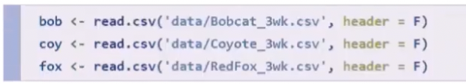

Header = false because doesn’t have a header, first row represents first site

Inspect fox detection/non-detection data:

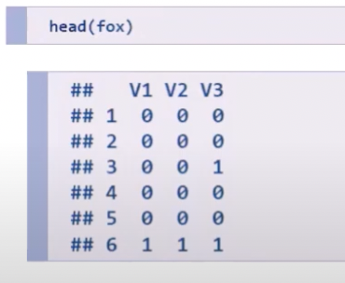

Each column is a replicate survey

Each row is a site

Load site-level covariate data (vary only by site but assume constant for duration of survey):



Inspect site-level covariates:

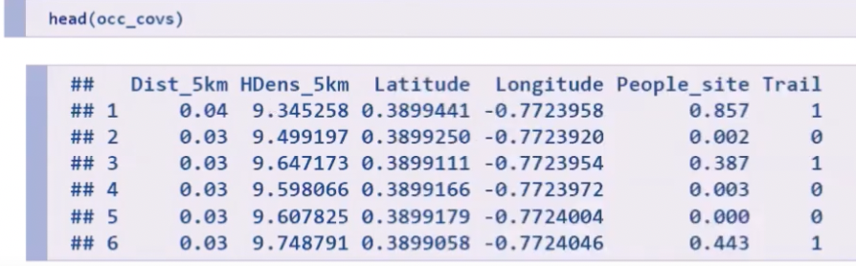

Load detection covariates:



Inspect detection covariates:

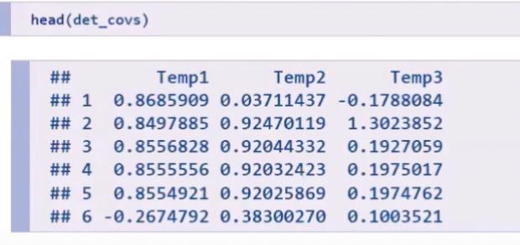

library(unmarked)

Place detection/non-detection data into a named list, each element is a matrix:

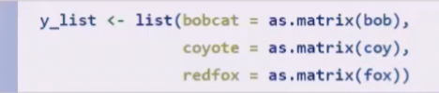

Place detection covariates into a named list:



Combine data into an unmarkedFrameOccuMulti object:

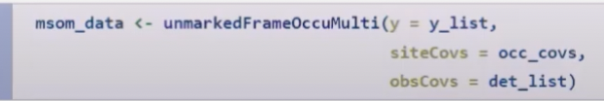

Y = detection/non-detection data

siteCovs = site-level covariates

obsCovs = observation covariates, list of detection covariates

**Intercept-only model, assuming independence:**

Detection formula for each species

Occupancy formula for each natural parameter

Formulas specified as character vector

Order of formulas follows detection/non-detection list

Code for fitting intercept-only model that assumes independence between each species:

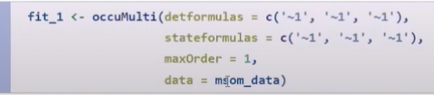

Summary (fitting 3 single-species occupancy models):

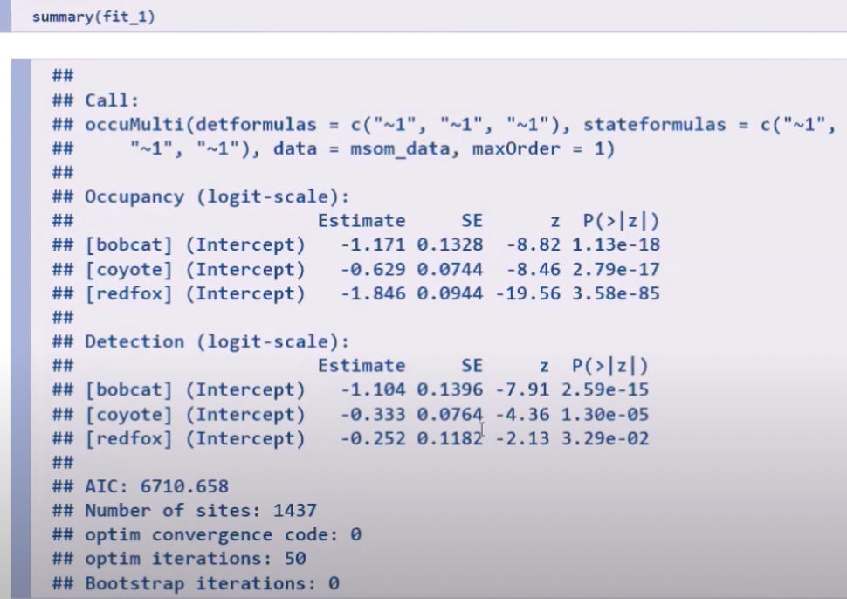

**Intercept-only model, assuming dependence:**

Estimate up to 2nd order natural parameters

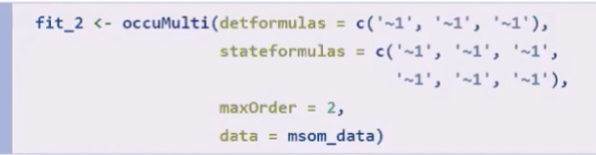

Summary:

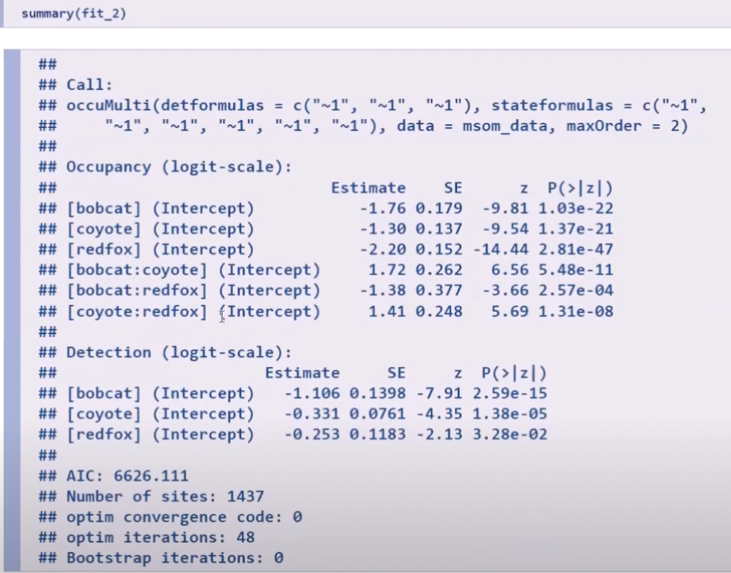

**Incorporating covariates:**

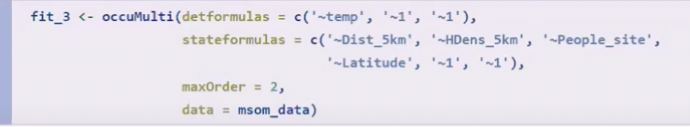

Model for 1st order natural parameters: [animal]

Model for 2nd order natural parameters: [animal1:animal2]

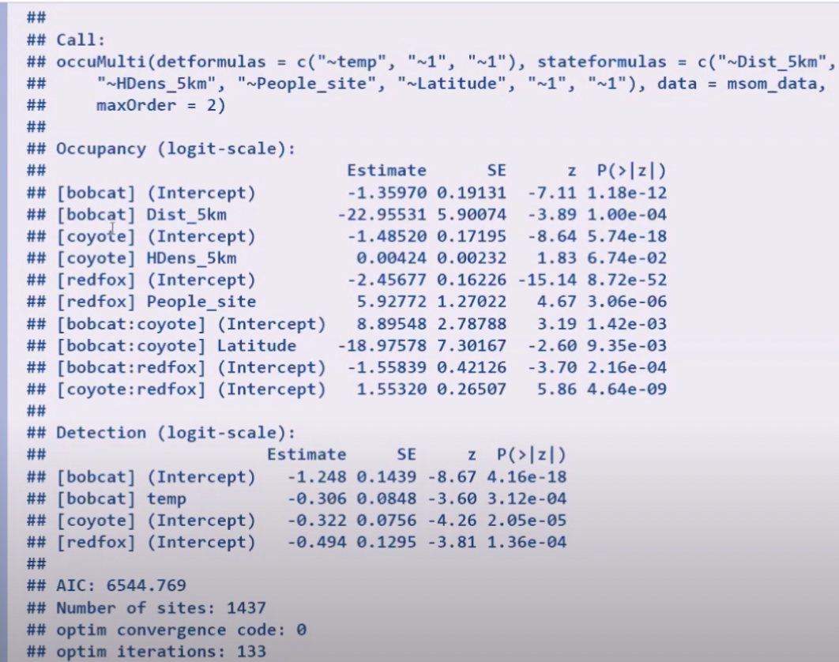

**Conditional occupancy probability:**

Conditional and marginal occupancy probabilities are implemented through the *predict* function.

Create a data.frame for predictions:

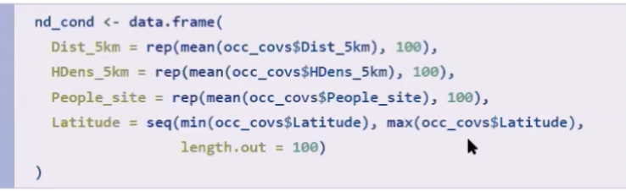

Predicting bobcat occurrence when coyotes are present:



Predicting bobcat occurrence when coyotes are absent:

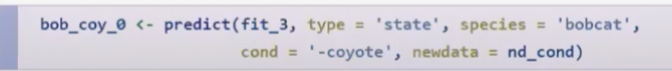

For making graphs:

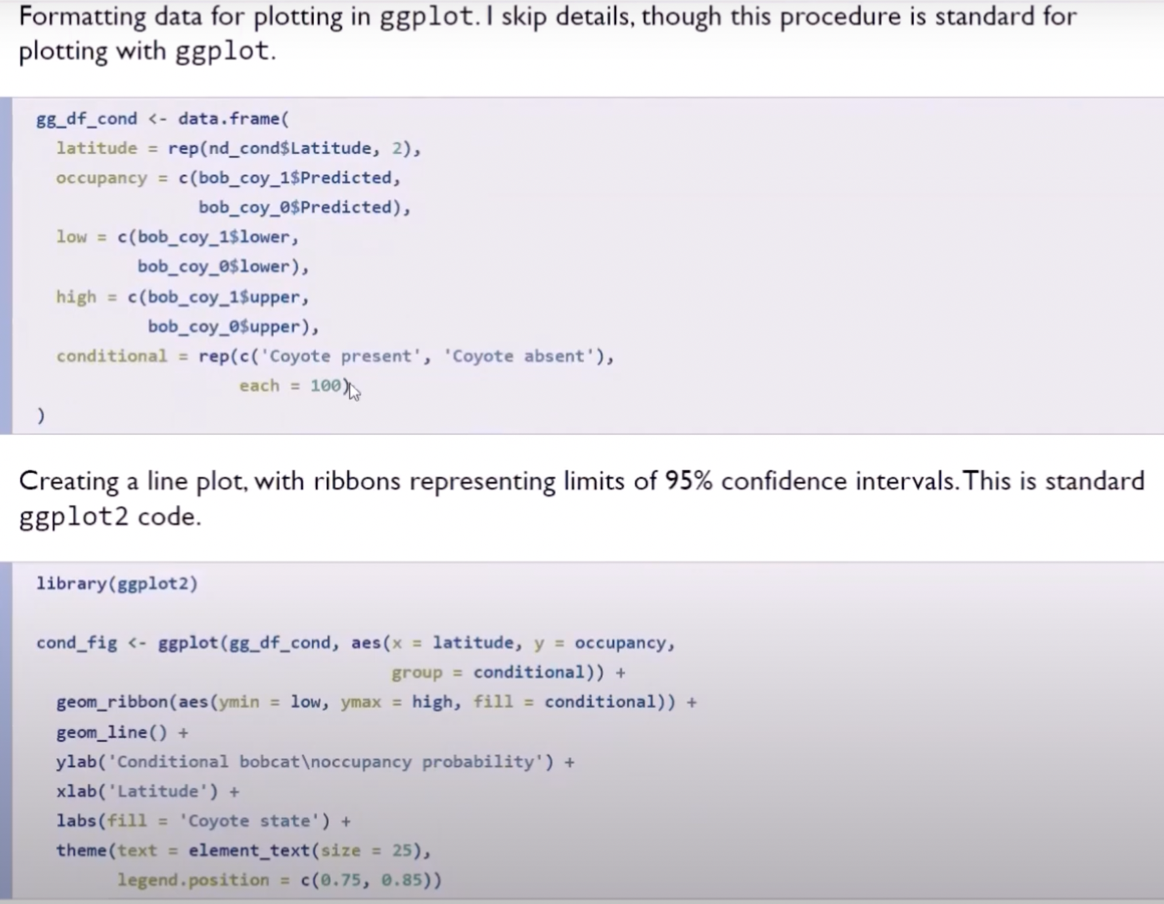

**Marginal occupancy probability:**



Formatting data for ggplot2

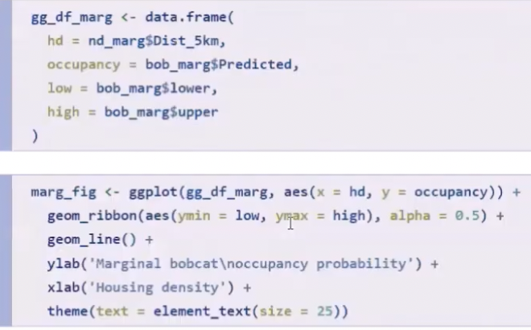

[**Video**](https://www.youtube.com/watch?v=u--F8_oRpVU)

AIC (Akaike Information Criterion) - relative information distance from ‘truth’

∆AIC = AIC – min(AIC) is what is important. Models with small values are more supported.